**AMERICAN INTERNATIONAL UNIVERSITY–BANGLADESH (AIUB)**

FACULTY OF ENGINEERING

Course name: Data Communication

Course code: COE 3201

Section: H

Semester: Spring 2023-24

Group-04

|  |
| --- |
|  |

|  |  |
| --- | --- |
| **NAME** | **ID** |
| EFFAT ARA | 22-46090-1 |
| MD. ABDULLAH SHISHIR | 22-46410-1 |
| FARJANA YESMIN OPI | 22-47018-1 |
| MD. ABU TOWSIF | 22-47019-1 |
| MOST. SAYMA KHATUN | 22-47035-1 |

Experiment No: **OEL**

Experiment Title: **Analog Shift: Exploring ASK and FDM**

**Multiplexing for Binary Communication**.

Submission date:

**Tittle:** Analog Shift: Exploring ASK and FDM Multiplexing for Binary Communication.

**Objectives:**

This experiment investigates the conversion of digital data into analog signals using Amplitude Shift Keying (ASK) and the multiplexing of these signals via Frequency Division Multiplexing (FDM). By converting multiple digital data streams into analog signals through ASK modulation and combining them using FDM, the experiment aims to explore the process of multiplexing. Subsequently, the demultiplexing of the composite analog signal back into individual analog signals is performed, demonstrating the ability to retrieve the original data streams.

**Introduction:**

**Frequency-division multiplexing (FDM)** is an analog technique that can be applied when the bandwidth of a link (in hertz) is greater than the combined bandwidths of the signals to be transmitted. In FDM, signals generated by each sending device modulate different carrier frequencies. These modulated signals are then combined into a single composite signal that can be transported by the link. Carrier frequencies are separated by sufficient bandwidth to accommodate the modulated signal. These bandwidth ranges are the channels through which the various signals travel. Channels can be separated by strips of unused bandwidth—guard bands—to prevent signals from overlapping. In addition, carrier frequencies must not interfere with the original data frequencies.

Figure 1 gives a conceptual view of FDM. In this illustration, the transmission path is divided into three parts, each representing a channel that carries one transmission.

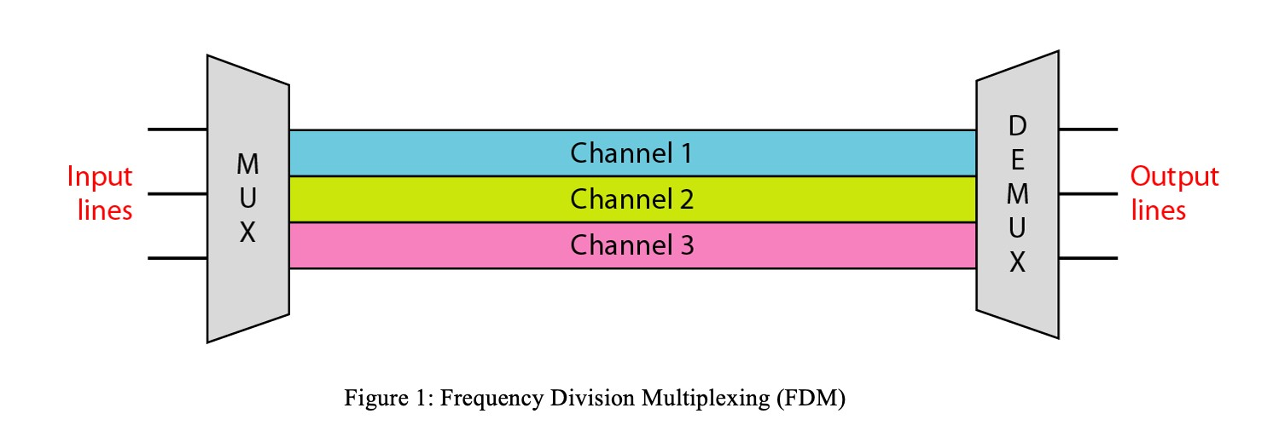

We consider FDM to be an analog multiplexing technique; however, this does not mean that FDM cannot be used to combine sources sending digital signals. A digital signal can be converted to an analog signal (Using ASK, FSK, PSK, QAM) before FDM is used to multiplex them.

**Multiplexing Process:** Figure 2 is a conceptual illustration of the multiplexing process. Each source generates a signal of a similar frequency range. Inside the multiplexer, these similar signals modulate different carrier frequencies ( f1, f2, and f3). The resulting modulated signals are then combined into a single composite signal that is sent out over a media link that has enough bandwidth to accommodate it.

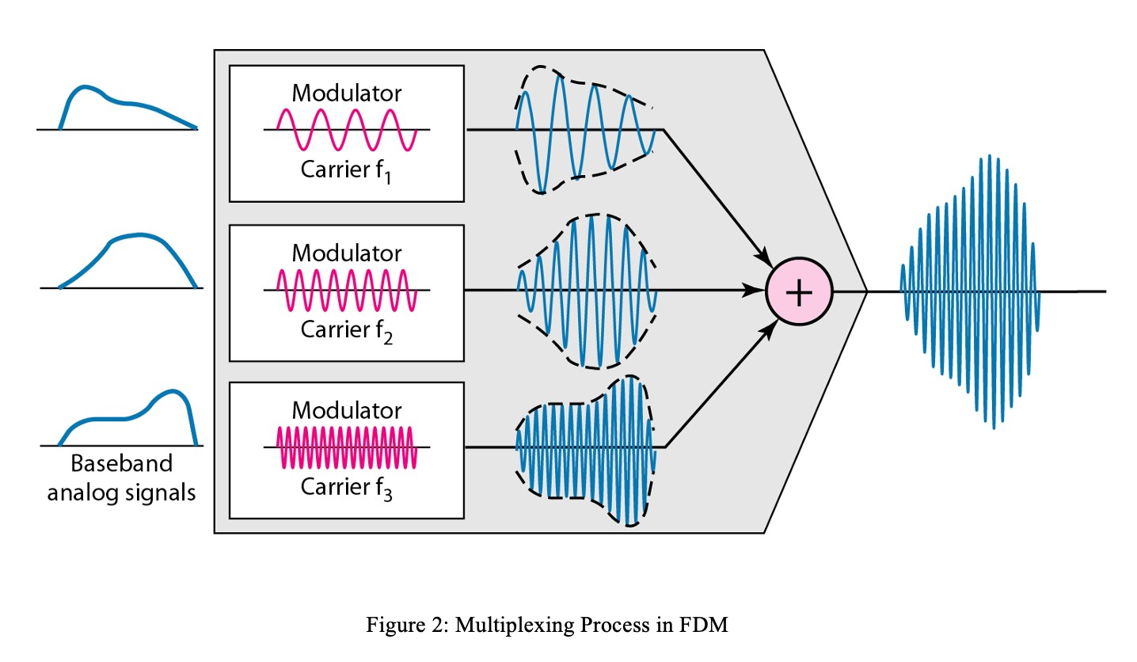

**Demultiplexing Process:** The demultiplexer uses a series of filters to decompose the multiplexed signal into its constituent component signals. The individual signals are then passed to a demodulator that separates them from their carriers and passes them to the output lines. Figure 3 is a conceptual illustration of demultiplexing process.

**Implementation:** FDM can be implemented very easily. In many cases, such as radio and television broadcasting, there is no need for a physical multiplexer or demultiplexer. As long a the stations agree to send their broadcasts to the air using different carrier frequencies, multiplexing is achieved. **To make sure we are transmitting signals in different frequencies we need to use AM, FM, PM with suitable carrier frequencies.** In other cases, such as the cellular telephone system, a base station needs to assign a carrier frequency to the telephone user. There is not enough bandwidth in a cell to permanently assign a bandwidth range to every telephone user. When a user hangs up, her or his bandwidth is assigned to another caller.

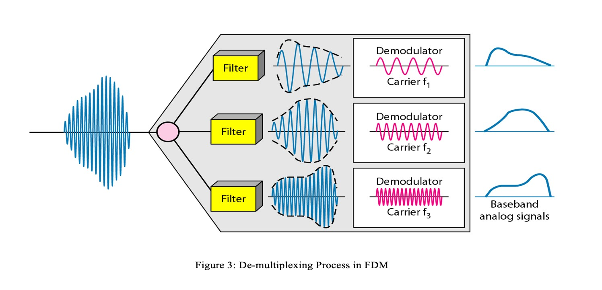

Digital data represented as binary bits are transformed into analog signals utilizing Amplitude Shift Keying (ASK), where the amplitude of the carrier signal is altered to encode the binary information. Subsequently, these analog signals are multiplexed using Frequency Division Multiplexing (FDM), allowing multiple signals to coexist by allocating distinct frequency bands for each signal. At the receiver end, the composite analog signal is demultiplexed, separating the individual analog signals for further processing or conversion back into binary data. This process demonstrates the transmission and reception of digital information through analog modulation and multiplexing techniques.

**Procedure:**

**1. Digital-to-Analog Conversion (ASK):**

The digital data, represented as binary bits, are first converted into analog signals using Amplitude Shift Keying (ASK) modulation. For each digital bit:

* If the bit is '0', the amplitude of the carrier signal is set to a lower level (e.g., 0 volts).
* If the bit is '1', the amplitude of the carrier signal is set to a higher level (e.g., 1 volt).

This process is repeated for all the digital bits to generate the corresponding analog signals.

1. **Multiplexing (FDM):**

Multiple analog signals obtained from the ASK modulation are then multiplexed using Frequency Division Multiplexing (FDM).

Each analog signal is assigned a unique frequency band within a specified frequency range.

These analog signals are combined into a composite signal by modulating them onto carrier waves of different frequencies.

1. **De-multiplexing:**

At the receiver end, the composite analog signal is received and fed into a de-multiplexing circuit.

This circuit separates the individual analog signals by filtering them based on their respective frequency bands.

Each filtered signal corresponds to one of the original analog signals generated during the ASK modulation.

1. **Analog-to-Digital Conversion:**

Finally, the individual analog signals are converted back into digital data.

This is achieved by sampling each analog signal at regular intervals and quantizing the sampled values into binary bits.

The resulting binary bits represent the original digital data that was transmitted.

**MATLAB code:**

% Parameters

Fs = 1000;

% Sampling frequency

T = 1/Fs;

% Sampling period

t = 0:T:1-T; % Time vector

% Digital data streams

data1 = randi([0, 1], 1, length(t));

% Example data stream 1

data2 = randi([0, 1], 1, length(t));

% Example data stream 2

% ASK Modulation

carrier_freq = 50; % Carrier frequency

A = 1; % Amplitude of the carrier wave

% Modulate data streams into analog signals

ask_signal1 = A * (data1 .* sin(2*pi*carrier_freq*t));

% Modulated signal 1

ask_signal2 = A * (data2 .* sin(2*pi*carrier_freq*t));

% Modulated signal 2

% Plot ASK-modulated signals figure;

subplot(2,1,1);

plot(t, ask_signal1);

title('ASK-modulated Signal 1');

xlabel('Time');

ylabel('Amplitude');

subplot(2,1,2);

plot(t, ask_signal2);

title('ASK-modulated Signal 2');

xlabel('Time');

ylabel('Amplitude');

% Frequency Division Multiplexing (FDM)

f1 = 50;

% Frequency of signal 1

f2 = 75;

% Frequency of signal 2

composite_signal = ask_signal1 + ask_signal2;

% Composite FDM signal

% Plot composite FDM signal

figure;

plot(t, composite_signal);

title('Composite FDM Signal');

xlabel('Time');

ylabel('Amplitude');

% Demultiplexing the composite FDM signal

demux_signal1 = A * (sin(2*pi*f1*t) .* composite_signal);

% Demodulated signal 1

demux_signal2 = A * (sin(2*pi*f2*t) .* composite_signal);

% Demodulated signal 2

% Plot demultiplexed signals

figure;

subplot(2,1,1);

plot(t, demux_signal1);

title('Demultiplexed Signal 1');

xlabel('Time');

ylabel('Amplitude');

subplot(2,1,2);

plot(t, demux_signal2);

title('Demultiplexed Signal 2');

xlabel('Time');

ylabel('Amplitude');

**Results (Output):**

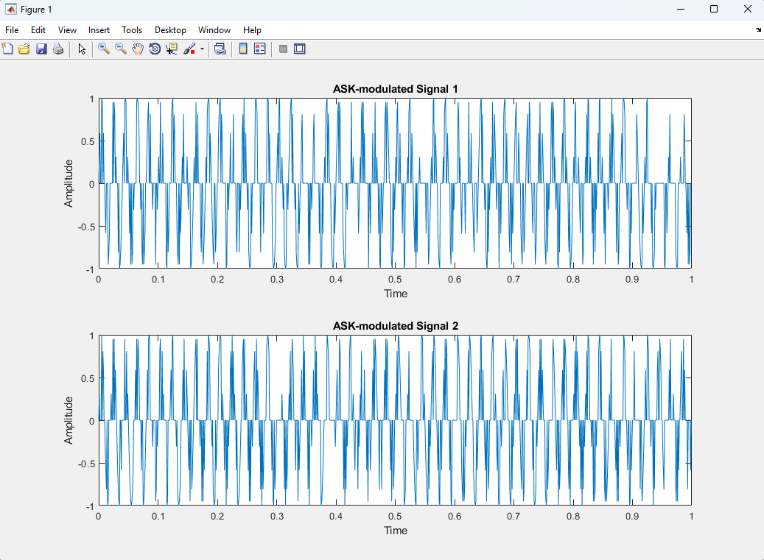

Figure 4 : ASK modulated Signal

Figure 5: Composite FDM Signal

Figure 6: Demultiplexer Signal

**The impact of Amplitude Shift Keying (ASK) and Frequency Division Multiplexing (FDM) on society, health, safety, and culture:**

1. **Society:** 
   * **Communication:** ASK and FDM are widely used in modern communication systems such as radio broadcasting, television transmission, and internet communication. They facilitate the efficient transmission of multiple signals over a shared medium, enabling widespread access to information and entertainment.
   * **Connectivity:** These technologies contribute to the interconnectedness of society by enabling seamless communication between individuals, organizations, and communities. This connectivity fosters collaboration, innovation, and socio-economic development.

1. **Health:** 
   * **Wireless Medical Devices:** ASK and FDM play a crucial role in wireless medical devices and telemedicine systems. These technologies enable remote monitoring of patients, facilitating timely healthcare interventions and improving patient outcomes.
   * **Wireless Communication in Healthcare Facilities:** In healthcare facilities, wireless communication systems based on ASK and FDM enhance communication between medical staff, enabling faster response times and better coordination of patient care.

1. **Safety:** 
   * **Emergency Communication:** ASK and FDM are utilized in emergency communication systems, including public safety radio networks and disaster response operations. These technologies enable reliable and efficient communication among emergency responders, enhancing coordination and facilitating timely assistance to those in need.
   * **Transportation Safety:** In transportation systems, ASK and FDM are employed in communication systems for air traffic control, railway signaling, and maritime navigation. They contribute to the safety and efficiency of transportation operations by facilitating communication between vehicles and control centers.

1. **Culture:** 
   * + **Media Consumption:** ASK and FDM influence cultural practices by shaping how people consume media and entertainment. These technologies enable the transmission of a wide range of content, including music, movies, news, and cultural programming, which contribute to the diversity and richness of cultural experiences.
     + **Global Connectivity:** ASK and FDM contribute to the globalization of culture by facilitating cross-border communication and the exchange of cultural ideas and perspectives. They enable people from different parts of the world to connect and engage with each other, fostering cultural exchange and understanding.

**Discussion and conclusions:**

The experiment delved into the practical implementation of Amplitude Shift Keying (ASK) modulation and Frequency Division Multiplexing (FDM) for binary communication. ASK effectively converted digital data into analog signals, with the amplitude of the carrier signal representing the binary information. Despite the simplicity of ASK modulation, challenges such as signal distortion may arise, affecting signal clarity. Additionally, the experiment showcased the efficacy of FDM in multiplexing multiple analog signals by allocating distinct frequency bands. While the process efficiently combined signals for transmission, potential issues such as interference between frequency bands need consideration. Moreover, at the receiver end, the demultiplexing of the composite analog signal successfully separated individual analog signals for further processing or conversion back into binary data. However, the process may encounter challenges like crosstalk, necessitating robust filtering mechanisms. Notably, the experiment provides valuable insights into communication systems and signal processing techniques, offering a practical demonstration of digital-to-analog conversion, multiplexing, and demultiplexing. Despite limitations, such as simplified simulations, the experiment lays a foundation for understanding the principles underlying binary communication. Future experiments could explore advanced modulation schemes and analyze the impact of noise on communication performance. The impact of Amplitude Shift Keying (ASK) and Frequency Division Multiplexing (FDM) extends beyond the laboratory, influencing various aspects of society, health, safety, and culture. In society, these technologies drive modern communication systems, enabling widespread access to information and fostering connectivity among individuals and communities. They play a crucial role in healthcare, facilitating remote patient monitoring and enhancing communication in medical settings. Additionally, ASK and FDM contribute to safety by supporting emergency communication systems and improving transportation operations' efficiency. Culturally, these technologies shape media consumption habits and contribute to global connectivity by facilitating cross-border communication and cultural exchange. Overall, ASK and FDM have a profound impact on modern life, driving innovation, connectivity, and cultural exchange.

**References:**

1. **" Digital Transmission Theory" by J. G. Proakis & M. Salehi (5th ed.)** (General overview of digital communication, including line coding)
2. **"MATLAB for Engineers" by H. Moore (4th ed.)** (General guide to using MATLAB for engineering applications)
3. **Line Coding Performance Analysis:** 
   1. **"Error-Performance of Line Codes" by G. D. Forney Jr., IEEE Transactions on Information Theory (1973)**
4. **MATLAB Implementation:** 
   1. **"Digital Signal Processing Using MATLAB" by V. K. Ingle & J. G. Proakis (4th ed.) V. Comparative Studies:**

**a. "A Comparative Study of Line Codes for Digital Transmission Systems" by G. D. Forney Jr., IEEE Transactions on Information Theory (1973)**